Team 1 Open Source Air Quality Monitoring

Week 21: May 29 - June 5

Sponsor: Dr. [David Burnett](mailto:dburnett@pdx.edu)

Advisor: Dr. John Acken

Team Members: [Adam Dezay](mailto:adezay@pdx.edu), [Manuel Garcia](mailto:manga2@pdx.edu), [Brandon Hippe](mailto:bhippe@pdx.edu), Mercedes Newton

**Team Review:**

* Team continued working on a rough draft of the final report as well as an academic report per Dr. Burnett’s suggestion
* Demonstrated 2 working nodes, received feedback on small additions to add
* Preparing to add low battery notice, update graphing script, and build 2 more nodes.
* Began working on the final poster

**Individual Review**

Adam Dezay:

Almost done with the final report draft (90%done), almost done with the website (75%), started on the final poster. Finishing up Wiki + github for clarity and to include latest information (95%), started on the academic report for Dr. Burnett(10%).

Manuel Garcia:

Troubleshot and repaired two PCBs, designed and started modifying the PCBs to have additional functionality (improve the charging circuitry and make the design more robust). Designed an integration for the low battery indicator to output to the msp430.

Brandon Hippe:

Worked to build 2 demo nodes, finalizing code and planning on working to build 2 more units to deploy. Finished power consumption testing and calculated sensor periods for all configurations for 3 month, 6 month, and 1 year battery life. Measurement periods were calculated so that each of the sensors in the configuration used approximately equal power on average. These results are available in tables 1, 2, and 3 below. Also calculated approximate log file size per node for each configuration and battery lifetime, shown in table 4.

Mercedes Newton:

Continued documentation efforts with Adam in regards to converting report to latex.

**Gantt Chart and Timeline Updates:**

Below is both the timeline of the projected project progress for spring term. Figure 1 represents the gantt chart for the term with expected completion dates beginning March 25th. All specific dates for the upcoming term are specified in the table below.

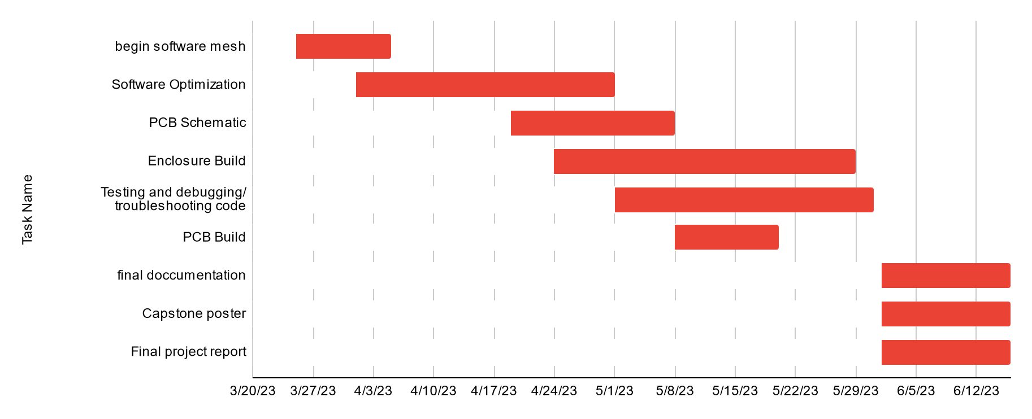

Figure One: Gantt chart for spring term (first task starts 3/25/2013)

| Task Name | Start date | End date |
| --- | --- | --- |
| Begin software mesh | 3/25/2023 | 4/5/2023 |
| Software Optimization | 4/1/2023 | 5/1/2023 |
| PCB Schematic | 4/19/2023 | 5/8/2023 |
| Enclosure Build | 4/24/2023 | 5/29/2023 |
| Testing and debugging/ troubleshooting code | 5/1/2023 | 5/31/2023 |
| PCB Build | 5/8/2023 | 5/20/2023 |
| final documentation | 6/1/2023 | 6/16/2023 |
| Capstone poster | 6/1/2023 | 6/16/2023 |
| Final project report | 6/1/2023 | 6/16/2023 |

| Sensor | 3 Months Battery Life | 6 Months Battery Life | 1 Year Battery Life |
| --- | --- | --- | --- |
| CO2 | 8 min (480 sec) | 17 min (1020 sec) | 37 min (2220 sec) |
| PM2.5 | 15 min (900 sec) | 32 min (1920 sec) | 72 min (4320 sec) |

Table One: Component Measurement Periods for 3 month, 6 month, and 1 year battery life for units without anemometer

| Sensor | 3 Months Battery Life | 6 Months Battery Life | 1 Year Battery Life |
| --- | --- | --- | --- |
| CO2 | 11 min (660 sec) | 22 min (1320 sec) | 51 min (3060 sec) |
| PM2.5 | 20 min (1200 sec) | 43 min (2580 sec) | 105 min (6300 sec) |
| Ultrasonic Anemometer | 0.167 min (10 sec) | 0.333 min (20 sec) | 0.667 min (40 sec) |

Table Two: Component Measurement Periods for 3 month, 6 month, and 1 year battery life for units with ultrasonic anemometer

| Sensor | 3 Months Battery Life | 6 Months Battery Life | 1 Year Battery Life |
| --- | --- | --- | --- |
| CO2 | 37 min (2220 sec) | 83 min (4980 sec) | 220 min (13200 sec) |
| PM2.5 | 43 min (2580 sec) | 97 min (5820 sec) | 260 min (15600 sec) |
| Hotwire Anemometer | 15 min (900 sec) | 33 min (1980 sec) | 86 min (5160 sec) |

Table Three: Component Measurement Periods for 3 month, 6 month, and 1 year battery life for units with hotwire anemometer

| Configuration | 3 Months Battery Life (Log file size after 3 months) | 6 Months Battery Life (Log file size after 6 months) | 1 Year Battery Life (Log file size after 1 year) |
| --- | --- | --- | --- |
| Without Anemometer | ~820 KB | ~810 KB | ~700 KB |
| Ultrasonic Anemometer | ~16.15 MB | ~16.14 MB | ~16.27 MB |
| Hotwire Anemometer | ~370 KB | ~334 KB | ~258 KB |

Table Four: Log file sizes after draining batteries for each configuration set to 3 month, 6 month, and 1 year battery life